Tesoro,Meinard
Chan, Elijah

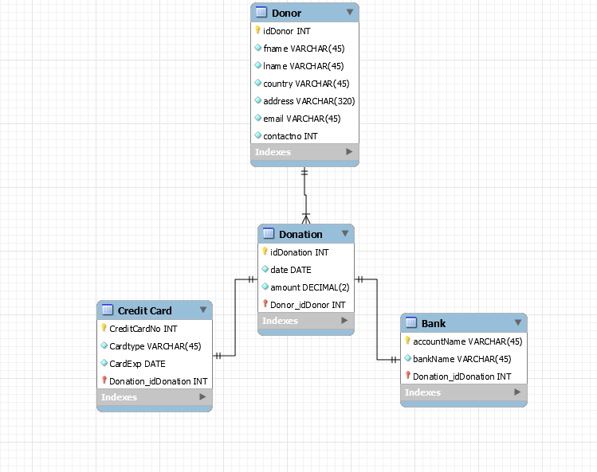
SCHEMA

This is the schema of the database. It is a parent-child relationship of Donor and Donation. The Donation also has children being Credit Card or Bank being the mode of donation being given to the website. It asks for basic information like name, address, email and contacts. The donation required the mode of payment, the date of donation, and the amount.

User Interface Storyboard

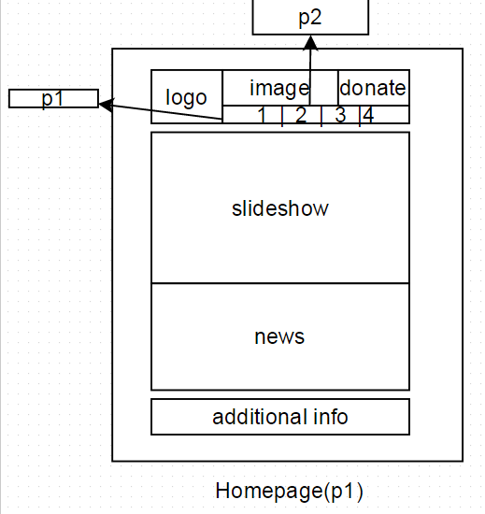

This is the homepage of the website. It includes all the links to navigate through the whole site from the homepage itself to the donate page. It also features a slide show of some of the projects we are funding ,show a featured news, and addtional info about how to contact us . Clicking on the news reveals more of the article

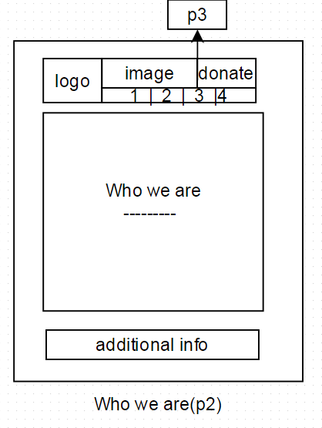

This page introduces our organization and gives some background information about it.

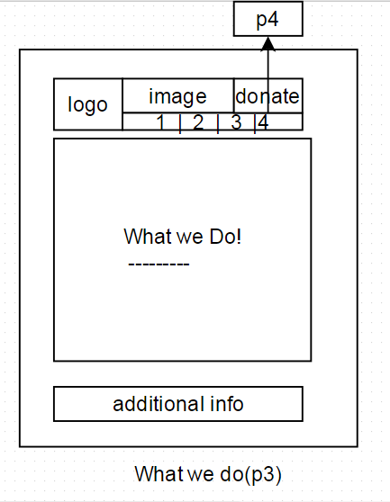

This page tells on what we do as an organization.

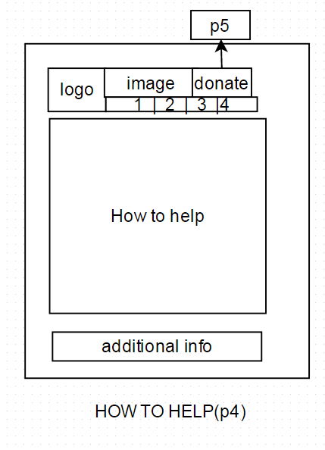
This page shows on how to help our organization. You either donate or volunteer.

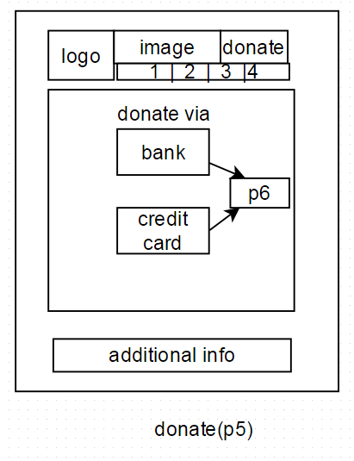

This page is the donate page. It links from the big donate buttong in the upper right corner of every page. From here you can choose on how you donate via bank or credit card which leads to p6

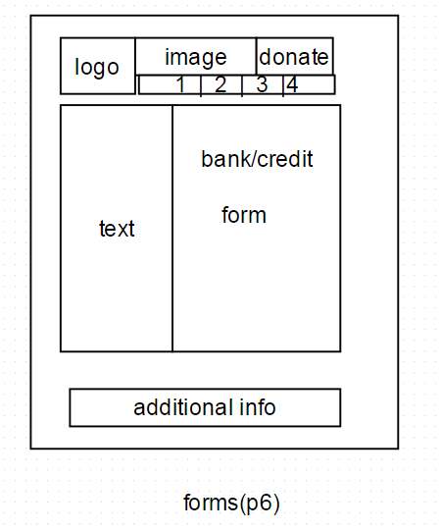

This a dynamic web content that creates a form that is suitable on how you will donate. Which will have a confirmation and another content that will notifty a successful transaction.

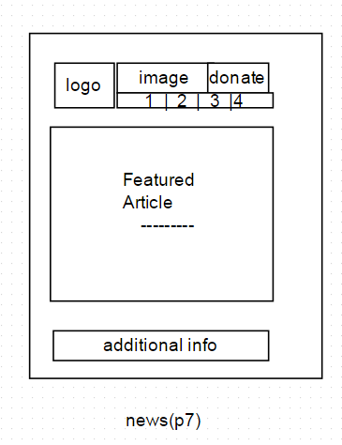

This page is a dynamic web page that is based on which article is featured on the time that it was opened. This is linked in p1 which have a preview of the said article.

